|  |  |  |  |  |  |
| --- | --- | --- | --- | --- | --- |
| Date | 6-Dec-22 | | | Tester Name | Mohammad Yusuf |
| Environment | Penfax - Test | | | Login used |  |
| Operating System | Windows | Version: | Update: | | |
| Software Used | Select Software | Version: | Update: | | |
| Select Software | Version: | Update: | | |
| Release version |  | | | | |
| Title |  | | | | |
| Test Type | Regression | | | | |
| Test Scenario |  | | | | |
|  |  | | | | |
| Expected Results |  | | | | |
| Pass/Fail | Select | | | JIRA# | N/A |

Describe your steps with screenshots:

Pre-condition: Login into the application.

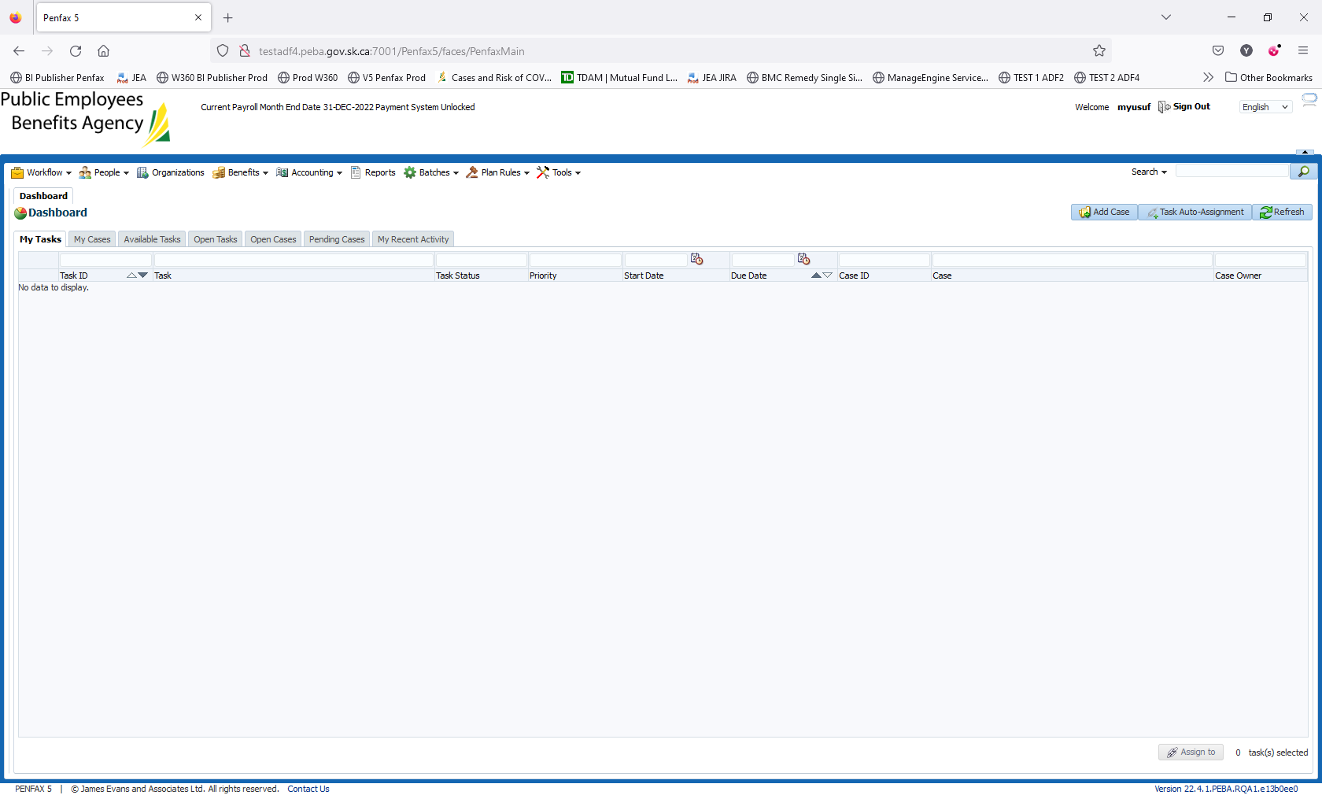

Click on Reports on top bar

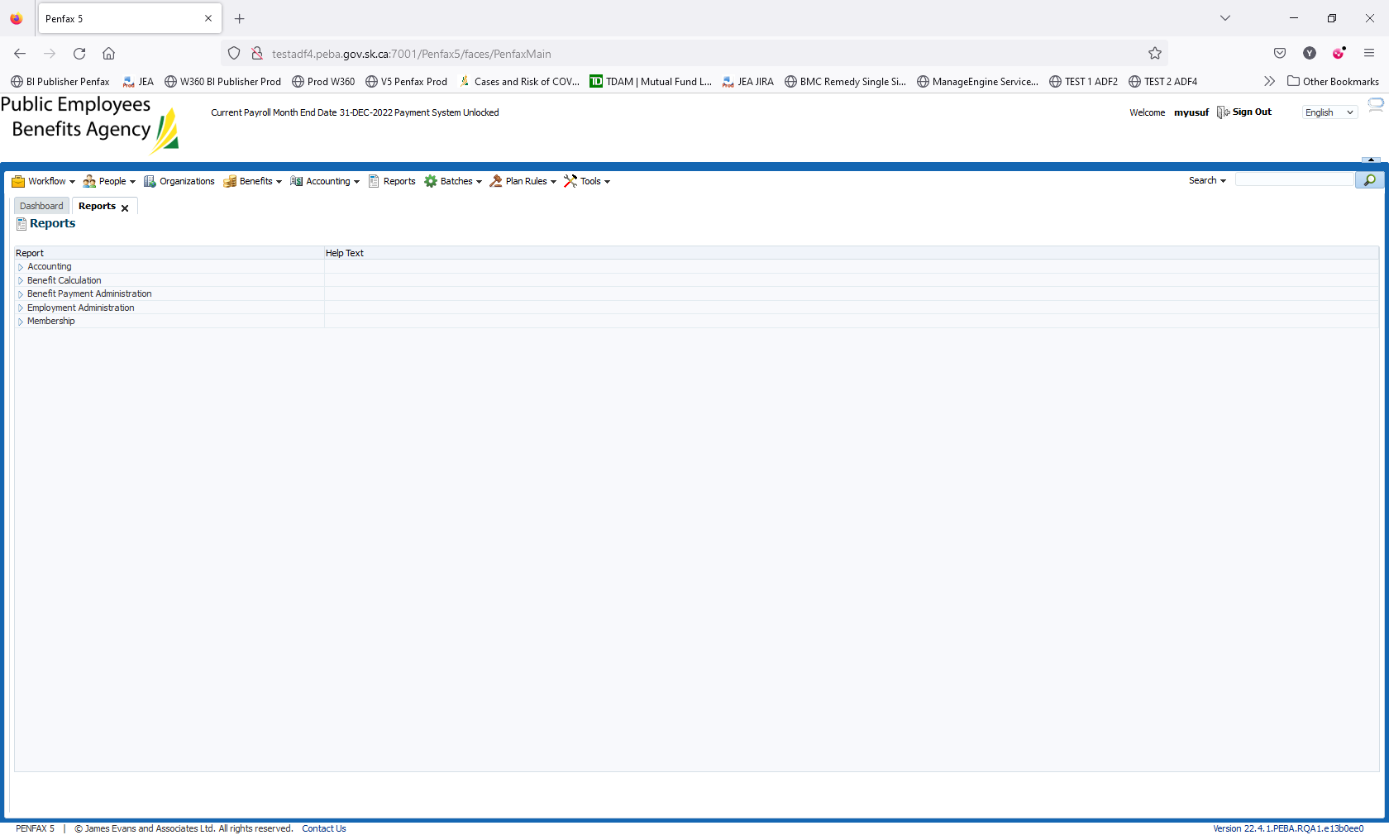

Expand the Employment Administration

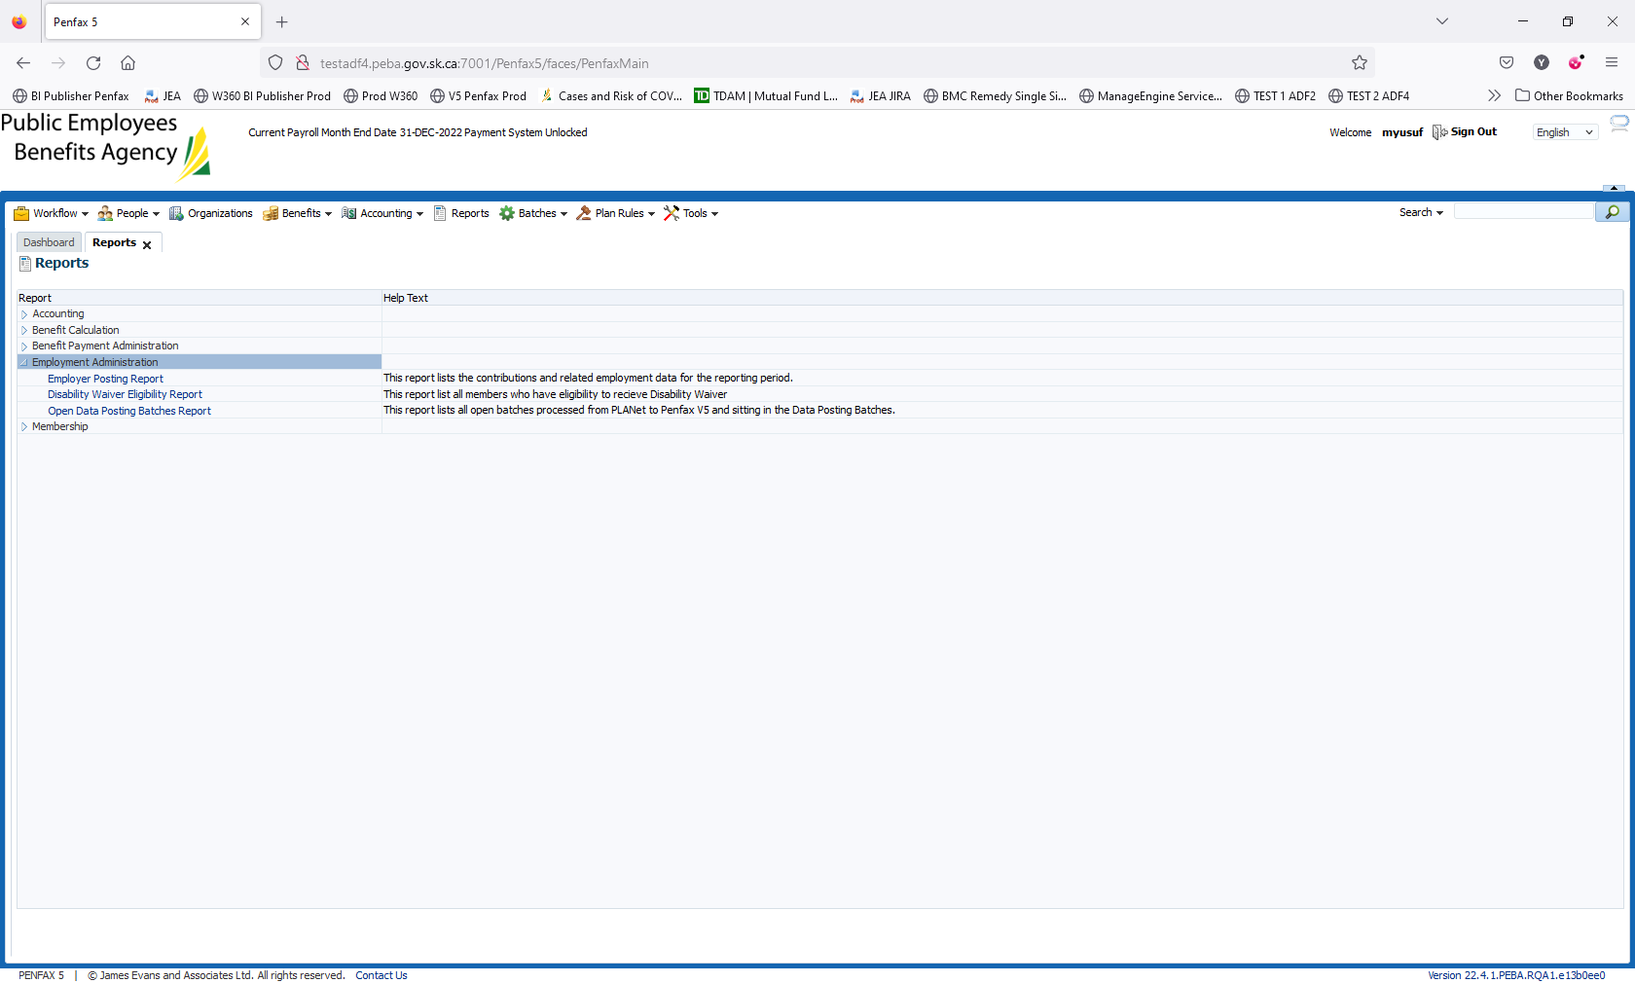

Click on the report – Disability Wavier Eligibility Report

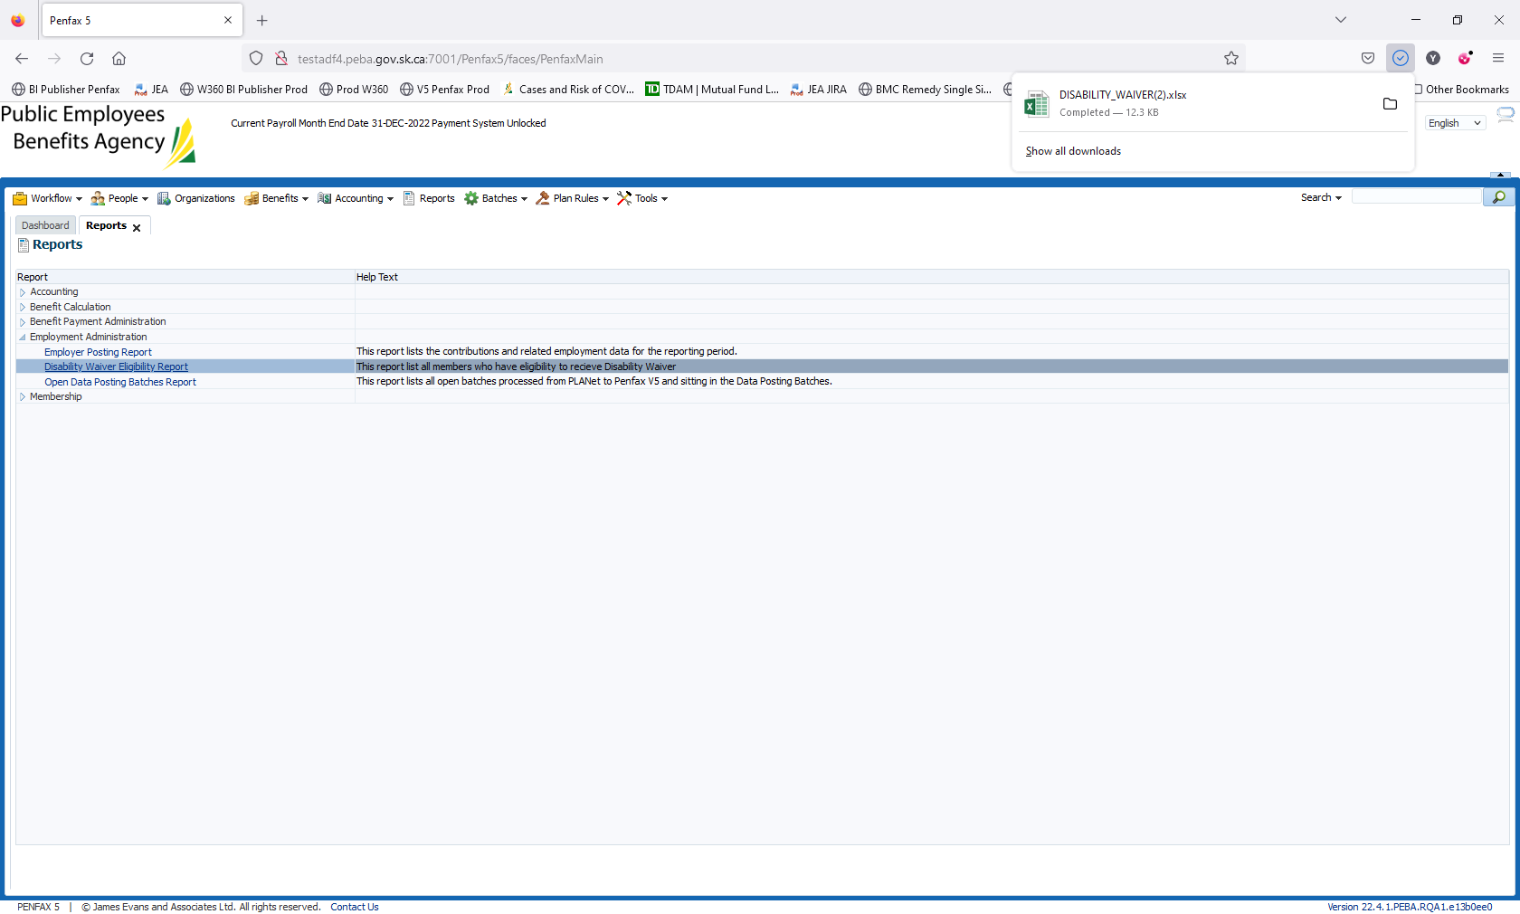

Completed the Test using prod. Region

After clicking on the report. It should start getting downloaded

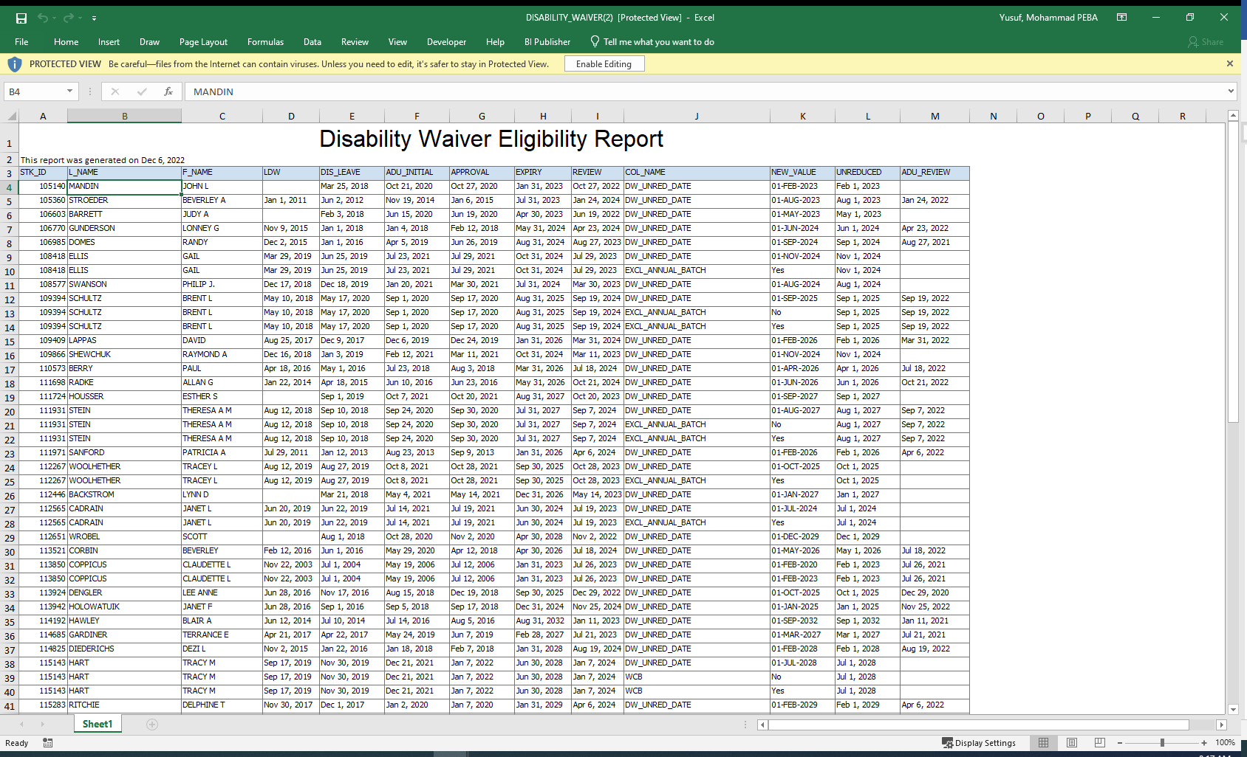

Click on the Disability_Wavier.xlsx. Report should open in Excel.

Validate the data using Penfax application. For example

Stakeholder details 105140 should match the Penfax details

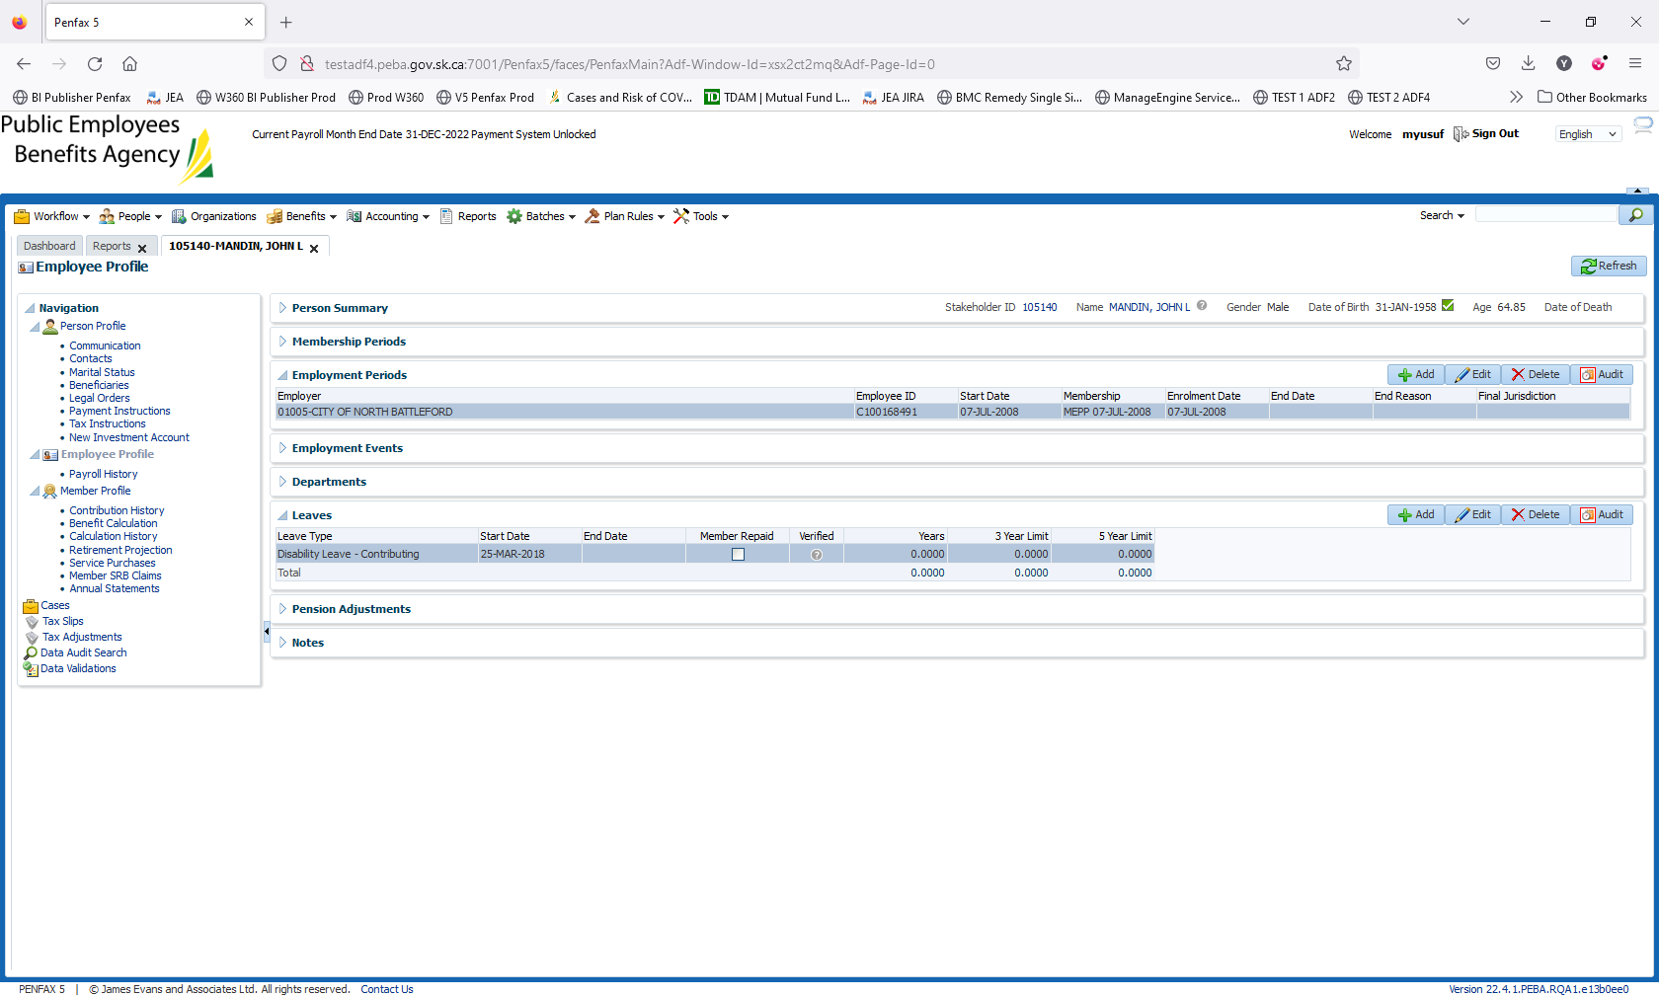

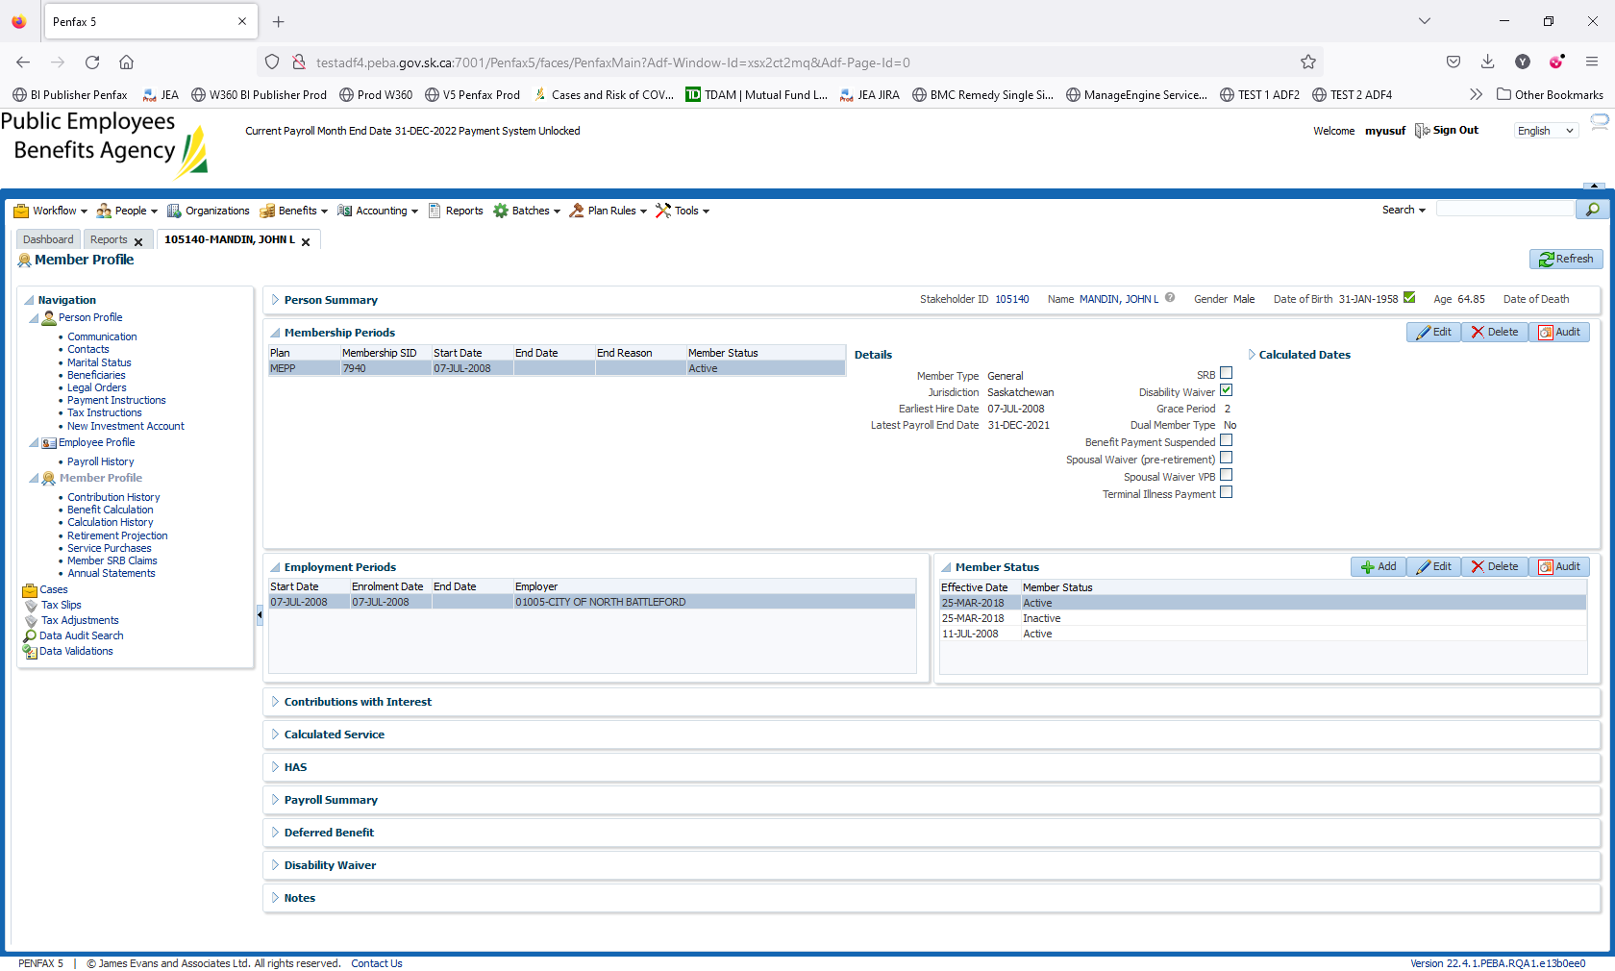

Stakeholder details 105360

Details in report are matching Penfax

